CRVS

Version

Revision History

|  |  |  |  |
| --- | --- | --- | --- |
| **Date** | **Version** | **Description** | **Author** |
| 2009-26-01 | 1.0 | Initial | Kiteplex IT |

Table of Contents

1. Introduction 3

1.1 Purpose of this document 3

1.2 Intended Audience 3

1.3 Scope 3

2. General overview 3

2.1 General functioning 3

3. Detail explanation 3

3.1 Flow Diagram 4

3.2 Login 4

3.3 School list 5

3.4 Add new school 5

3.5 School Details 6

3.5.1 Edit Details 6

3.5.2 Teachers 6

3.5.3 Add new Teachers 6

3.5.4 Classes 7

3.5.5 Class Edit 7

3.5.6 Student detail edit 7

3.5.7 Add new students 8

# Introduction

## Purpose of this document

The purpose of this document is to give information about CRVS and how to use the school management system.

## Intended Audience

The intended audiences are:

* Teachers, to analyze the design and implementation of CRVS.
* CRVS team members.
* Future developers to extend or use some ideas of CRVS project.

## Scope

This document will describe the design and some technical issues of CRVS project.

# General overview

## General functioning

The following are the major system functionalities:

* Register user in CRVS web site
* Load the School lists
* User can create a new School Deffination
* Select a school to view the school-details page
* On the Edit School sub-tab user can edit school details
* Teachers sub-tab shows the full list of corresponding school
* Classes sub-tab contains all corresponding class list and complete list of students for each class
* Existing student’s details can be edited through Edit Student form
* New students can be created for the selected school by pressing the New button

# Detail explanation

## Flow Diagram

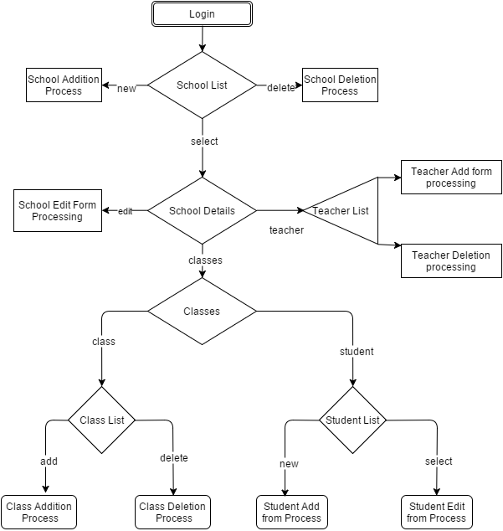

## Login

The following image shows the login window.

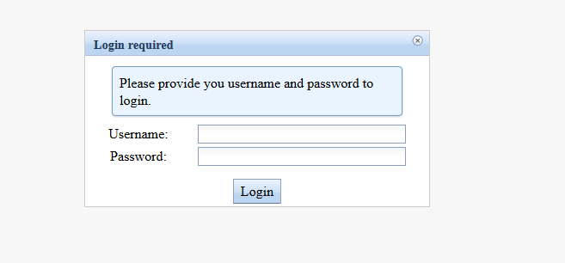

Figure 1: Login window

## School List



Figure 2: Login window

## Add New School

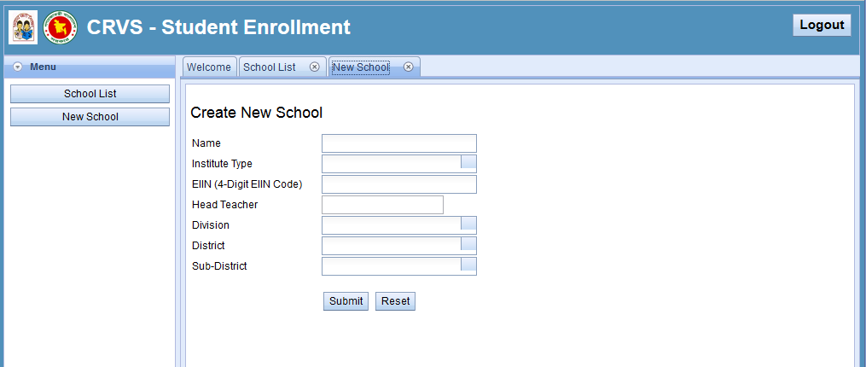

Figure 3: New School creation

## School Details

### Edit School

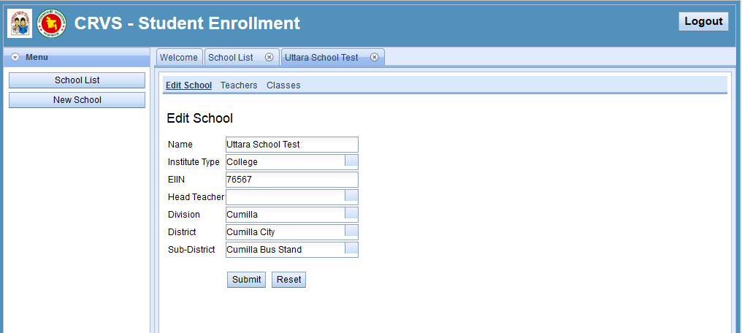

Figure 4: Edit school

### Teachers

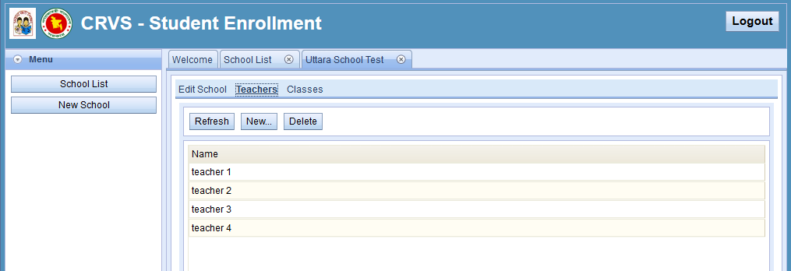

Figure 5: Teacher list

### Add new teacher

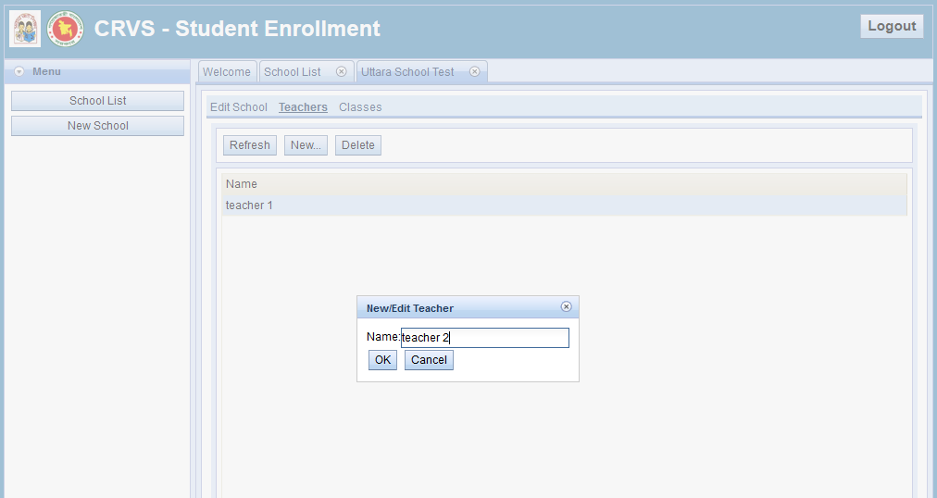

Figure 6: Add new teacher

### Classes

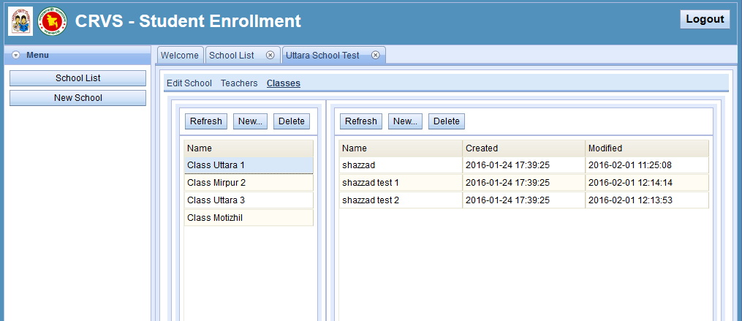

Figure 7: class details page

### Class Edit

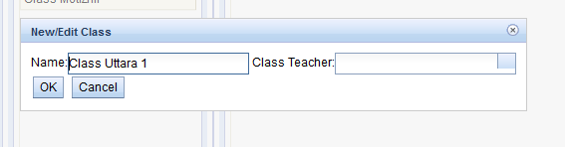

Figure 8: class edit

### Student detail edit

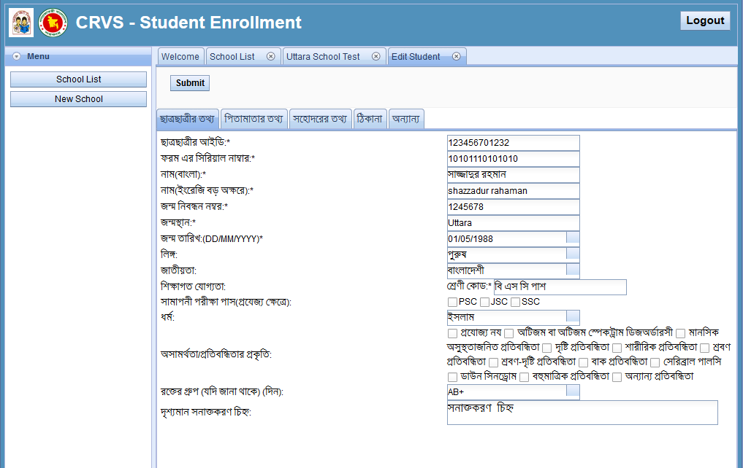

Figure 9: student detail edit form

### Add new students

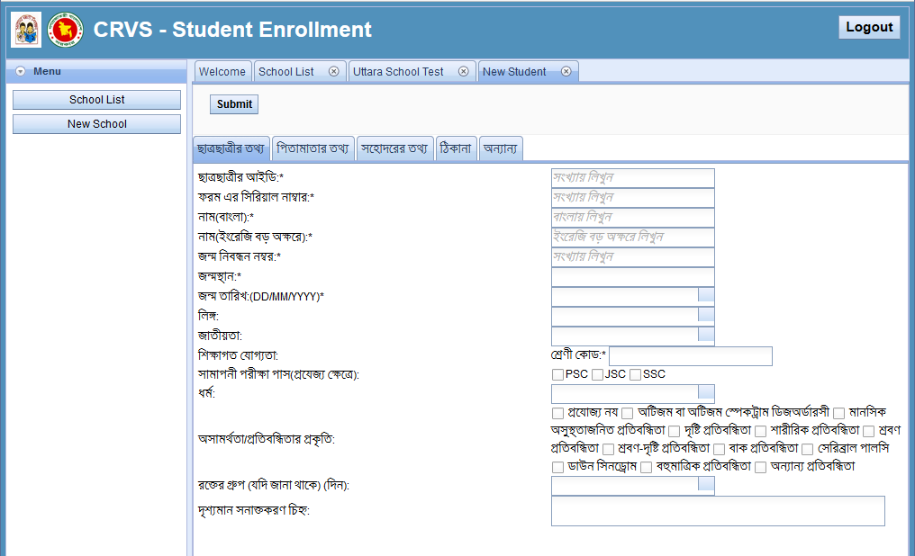

Figure 10: add new student form